Highly confidential Security System
Objective:
Highly confidential Security System is an online application to be built as a product that the system will help user in logging in to the client system for which it is holding/storing the password, either by the software interface or directly by hardware interface.
Users of the System:
- Admin
- User
Functional Requirements:
- Build an application that user can use the Security System (Software and hardware).
- The application should have a mail id and password locker.
- This application should have a Bank account information locker.
- This application should have a Video, Audio, Image locker.
- Also, an integrated platform required for admin and customer.

While the above ones are the basic functional features expected, the below ones can be nice to have add-on features:
- Build such that it is difficult to hack through.
- Multi-factor authentication for the sign-in process

Output/ Post Condition:
- Admin report
- Viewable and downlable reports with password protection
- Standalone application / Deployed in an app Container

Non-Functional Requirements:

Security | - App Platform –UserName/Password-Based Credentials  - Sensitive data has to be categorized and stored in a secure manner  - Secure connection for transmission of any data
Performance | - Peak Load Performance  - Highly confidential Security System -< 3 Sec  - Admin application < 2 Sec  - Non Peak Load Performance
Availability | - 99.99 % Availability
Standard Features | - Scalability  - Maintainability  - Usability  - Availability  - Failover
Logging & Auditing | - The system should support logging(app/web/DB) & auditing at all levels
Monitoring | - Should be able to monitor via as-is enterprise monitoring tools
Cloud | - The Solution should be made Cloud-ready and should have a minimum impact when moving away to Cloud infrastructure
Browser Compatible | - IE 7+  - Mozilla Firefox Latest – 15  - Google Chrome Latest – 20  - Mobile Ready

Technology Stack
Front End | React 16+  Google Material Design  Bootstrap / Bulma
Server Side | Spring Boot  Spring Web (Rest Controller)  Spring Security  Spring AOP  Spring Hibernate
Core Platform | OpenJDK 11
Database | MySQL or H2

Platform Pre-requisites (Do’s and Don’ts):
- The React app should run in port 8081.
- Spring boot app should run in port 8080.

Key points to remember:
- The id (for frontend) and attributes(backend) mentioned in the SRS should not be modified at any cost. Failing to do may fail test cases.
- Remember to check the screenshots provided with the SRS. Strictly adhere to id mapping and attribute mapping. Failing to do may fail test cases.
- Strictly adhere to the proper project scaffolding (Folder structure), coding conventions, method definitions and return types.
- Adhere strictly to the endpoints given below.

Application assumptions:
- The login page should be the first page rendered when the application loads.
- Manual routing should be restricted by using AuthGaurd by implementing the canActivate interface. For example, if the user enters as http://localhost:4200/signup or http://localhost:4200/home the page should not navigate to the corresponding page instead it should redirect to the login page.
- Unless logged into the system, the user cannot navigate to any other pages.
- Logging out must again redirect to the login page.
- To navigate to the admin side, you can store a user type as admin in the database with a username and password as admin.
- Use admin/admin as the username and password to navigate to the admin dashboard.

Validations:
- Basic email validation should be performed.
- Basic mobile validation should be performed.
Project Tasks:
API Endpoints:
USER
Action | URL | Method | Response
Login | /login | POST | true/false
Signup | /signup | POST | true/false
Get Bank Information | /bank | GET | Array of Bank details
Add Bank Information | /bank/{id} | POST | Information Added Successfully
Update Bank Information | /bank/{id} | PUT | Information Updated
Delete Bank Information | /bank/{id} | DELETE | Information Deleted
Get Media Information | /media | GET | Array of Media Details
Add Media | /media/{id} | POST | Media Added
Update Media | /media/{id} | PUT | Media Updated
Delete Media | /media/{id} | DELETE | Media Removed
Get Credentials Information | /credentials | GET | Array of Credentials details
Add Credentials Information | /credentials/{id} | POST | Credentials Added Successfully
Update Credentials Information | /credentials/{id} | PUT | Credentials Updated
Delete Credentials Information | /credentials/{id} | DELETE | Credentials Deleted
ADMIN
Action | URL | Method | Response
Get All Users | /admin/user | GET | Array of users
Approve User | /admin/approveUser | POST | Approved Successfully
Remove User | /admin/delete/{id} | DELETE | User Removed
Update User | /admin/update /{id} | UPDATE | User Updated
Get Specific User | /admin/user /{id} | GET | Particular User Detail

Frontend:
User:
Login:
Output Screenshot:
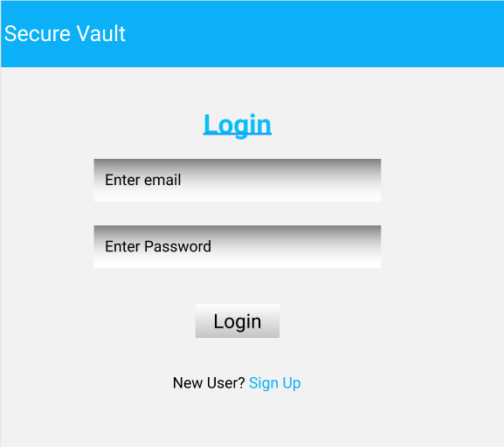

Signup:
Output Screenshot:
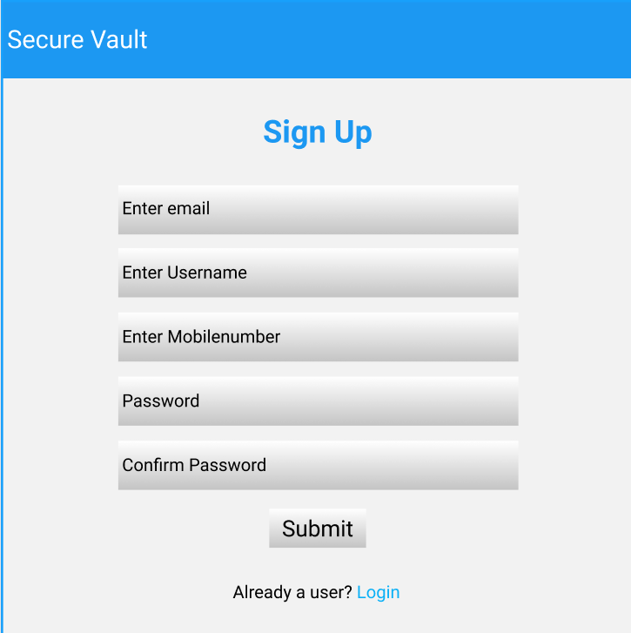

Home:
Output Screenshot:
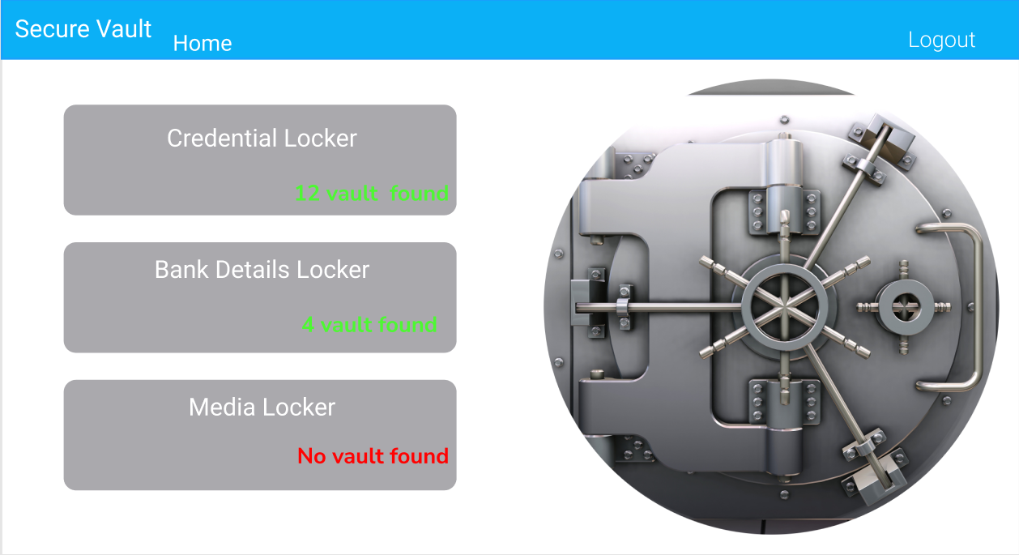
Credential Locker:
Output Screenshot:
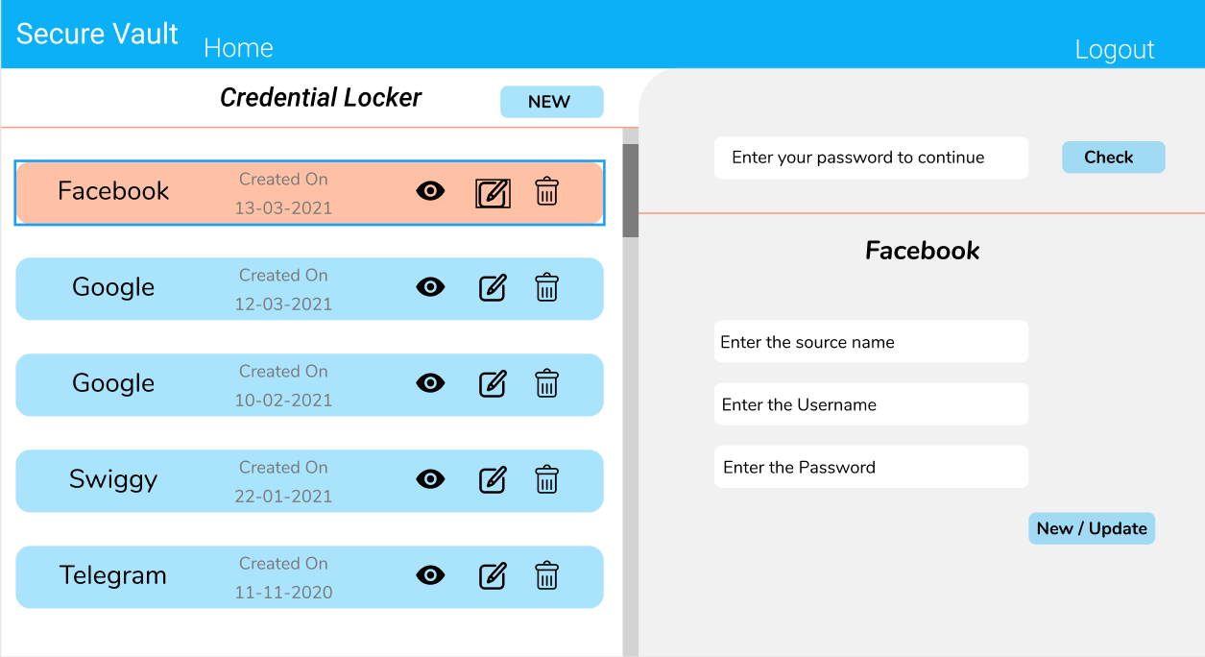

Bank Info Locker:
Output Screenshot:
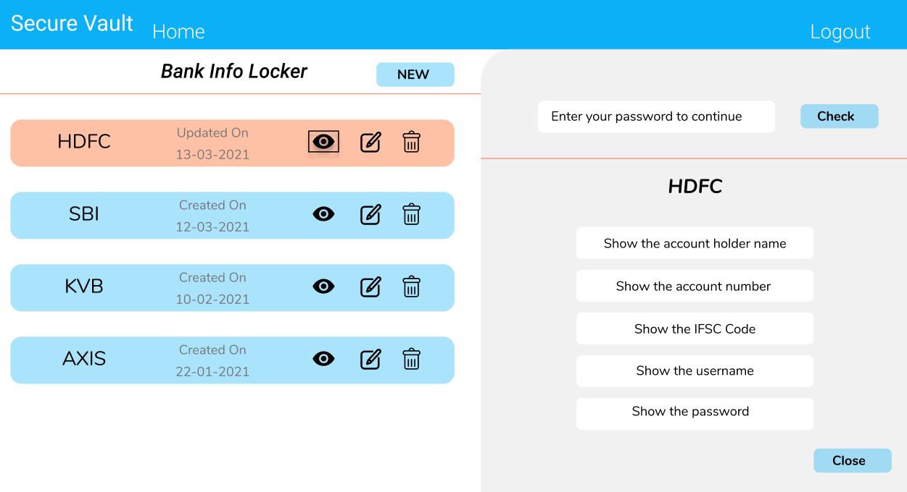
Media Locker:
Output Screenshot:
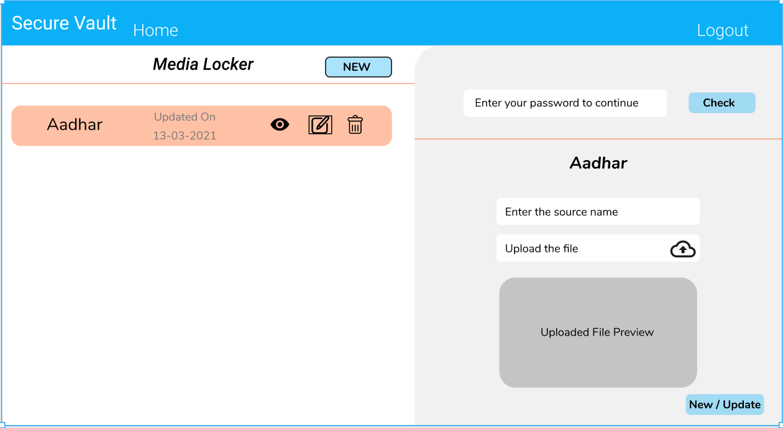

Admin:
Home:
Output Screenshot:
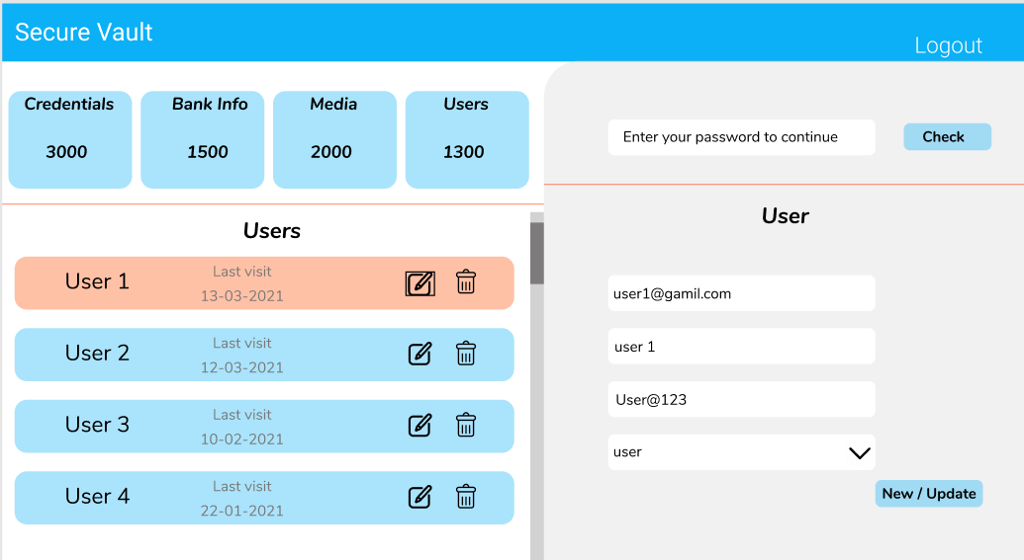

Backend:
Class and Method description:

Model Layer:

- UserModel: This class stores the user type (admin or the User) and all user information.
  - Attributes:
    - email: String
    - password: String
    - mobileNumber: String
    - active: Boolean
    - role: String
  - Methods: -
- LoginModel: This class contains the email and password of the user.
  - Attributes:
    - email: String
    - password: String
  - Methods: -
- BankValutModel: This class stores the encrypted Bank information.
  - Attributes:
    - valutId: String
    - userId: UserModel
    - accountNumber: Long
    - accountName: String
    - IFSC: String
    - userName: String
    - password: String
  - Methods: -
- MediaValutModel: This class stores the encrypted media information.
  - Attributes:
    - valutId: String
    - userId: UserModel
    - mediaName: String
    - image: Blob
    - video: Blob
    - audio: Blob
  - Methods: -
Controller Layer:
- SignupController: This class control the user signup
  - Attributes: -
  - Methods:
    - saveUser(UserModel user): This method helps to store users in the database and return true or false based on the database transaction.
- LoginController: This class controls the user login.
  - Attributes: -
  - Methods:
    - checkUser(LoginModel data): This method helps the user to sign up for the application and must return true or false
- BankValutController: This class controls the add/edit/update/view Bank information.
  - Attributes: -
  - Methods:
    - List< BankValutModel > getBankInfo(): This method helps the User to fetch their all bank information from the database.
    - BankValutModel bankInfoById(String id): This method helps to retrieve a Bank information from the database based on the valut id.
    - bankInfoEditSave(BankValutModel data): This method helps to edit a Bank information and save it to the database.
    - bankInfoSave(BankValutModel data): This method helps to add a new Bank information to the database.
    - bankInfoDelete (String id): This method helps to delete a Bank information from the database.
- MediaValutController: This class controls the add/edit/update/view Media information.
  - Attributes: -
  - Methods:
    - List< MediaValutModel > getMediaInfo(): This method helps the User to fetch their all Media information from the database.
    - MediaValutModel mediaInfoById(String id): This method helps to retrieve a Media information from the database based on the valut id.
    - mediaInfoEditSave(MediaValutModel data): This method helps to edit a Media information and save it to the database.
    - mediaInfoSave(MediaValutModel data): This method helps to add a new Media information to the database.
    - MediaInfoDelete (String id): This method helps to delete a Media information from the database

